

**FLY AWAY PLUS**

**DETAIL DESIGN DOCUMENT**

**Class Design**

**Project Code: FAP**

**Document Code: FAP_Class Design_v1.0_EN**

**Record of Change**

*A-Added M-Modified D-Deleted

|  |  |  |  |  |
| --- | --- | --- | --- | --- |
| Date | Item | A, M, D* | Change Description | Version |
| 2015/08/14 | Add new | A |  | V1.0 |
| 2015/08/20 | Package Diagram  Package Description | M |  | V1.1 |

Table of Contents

1. Introduction 5

1.1. Purpose 5

1.2. Definitions, Acronyms and Abbreviations 5

2. Package 6

2.1. Package Diagram 6

2.2. Package Description 7

2.2.1. Model 7

2.2.2. View 9

2.2.3. Controller 9

3. Function 12

3.1. Search 12

3.1.1. Class Diagram 12

3.1.2. Sequence Diagram 13

3.2. Help Center (Undone) 14

3.3. Suggest 14

3.3.1. Class Diagram 14

3.3.2. Sequence Diagram 14

3.4. Post Management 15

3.4.1. Class Diagram 15

3.4.2. Sequence Diagram 16

3.5. Share Management (Undone) 18

3.6. Comment Management 18

3.6.1. Class Diagram 18

3.6.2. Sequence Diagram 19

3.7. Like Management 20

3.7.1. Class Diagram 20

3.7.2. Sequence Diagram 21

3.8. Report 23

3.8.1. Class Diagram 23

3.8.2. Sequence Diagram 24

3.9. Chat 25

3.9.1. Class Diagram 25

3.9.2. Sequence Diagram 25

3.10. Friend Management 26

3.10.1. Class Diagram 26

3.10.2. Sequence Diagram 27

3.11. Room (Undone) 28

3.12. Account Management 28

3.12.1. Class Diagram 28

3.12.2. Sequence Diagram 28

# Introduction

## Purpose

Fly Away Plus class design document contains descriptions of all classes of the Fly Away Plus. It includes:

* Class diagrams that describe the static relation of all classes in the system.

## Definitions, Acronyms and Abbreviations

|  |  |  |
| --- | --- | --- |
| Abbreviations | Description | Comment |
| FAP | Fly Away Plus |  |
| FAQ | Frequently Asked Question |  |

# Package

## Package Diagram

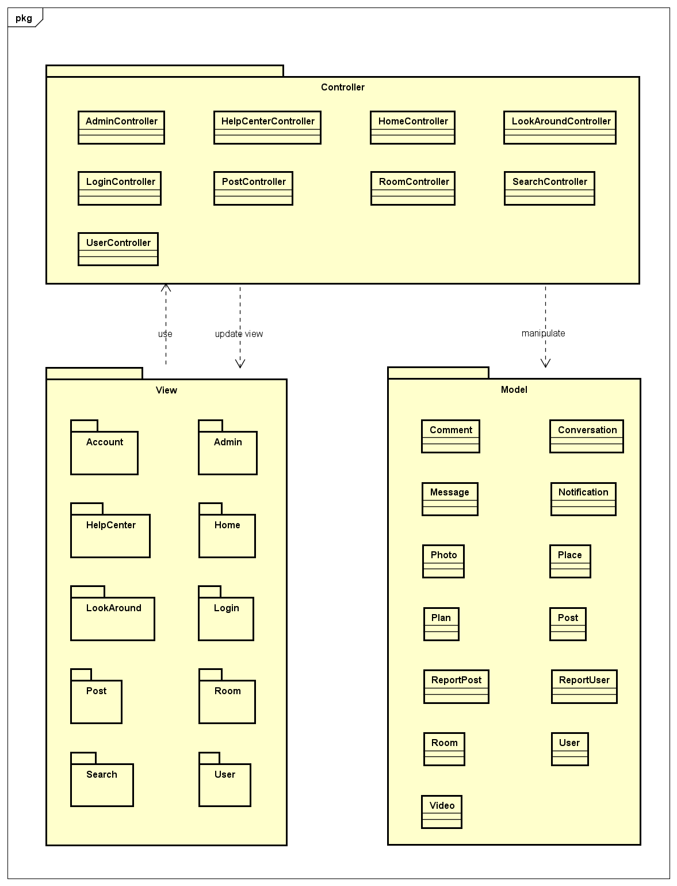

*Package Diagram*

## Package Description

### Model

#### Comment

|  |  |  |  |  |  |
| --- | --- | --- | --- | --- | --- |
| No | Attributes | Type | Default | Note | Description |
|  | commentID | int |  |  | Comment’s ID |
|  | content | String |  |  | Comment’s content |
|  | dateCreated | String |  |  | Comment’s created date. Auto-created while uploading |

#### Conversation

|  |  |  |  |  |  |
| --- | --- | --- | --- | --- | --- |
| No | Attributes | Type | Default | Note | Description |
|  | conversationID | String |  | public | Conversation’s ID |
|  | dateCreated | String |  | public | Conversation’s created date. Auto-created while creating conversation |

#### Message

|  |  |  |  |  |  |
| --- | --- | --- | --- | --- | --- |
| No | Attributes | Type | Default | Note | Description |
|  | messageID | int |  | public | Message’s ID |
|  | content | String |  | public | Message’s content |
|  | dateCreated | String |  | public | Message’s created date. Auto-created while creating conversation |

#### Notification

|  |  |  |  |  |  |
| --- | --- | --- | --- | --- | --- |
| No | Attributes | Type | Default | Note | Description |
|  | activity | String |  | public | Activity type of notification |
|  | dateCreated | String |  | public | Notification’s created date. Auto-created while creating conversation |
|  | user | user |  | public |  |
|  | post | post |  | public |  |
|  | lastActivityID | Int16 |  | public |  |

#### Photo

|  |  |  |  |  |  |
| --- | --- | --- | --- | --- | --- |
| No | Attributes | Type | Default | Note | Description |
|  | photoID | int |  |  | Photo’s ID |
|  | url | String |  |  | Photo’s URL |
|  | dateCreated | String |  |  | Photo’s created date. Auto-created while uploading |

#### Place

|  |  |  |  |  |  |
| --- | --- | --- | --- | --- | --- |
| No | Attributes | Type | Default | Note | Description |
|  | placeID | int |  |  | Place’s ID |
|  | name | String |  |  | Place’s name |
|  | latitude | Decimal |  |  | Place’s latitude |
|  | longitude | Decimal |  |  | Place’s longitude |

#### Plan

|  |  |  |  |  |  |
| --- | --- | --- | --- | --- | --- |
| No | Attributes | Type | Default | Note | Description |
|  | PlanID | int |  |  | Plan’s ID |
|  | WorkItem | String |  |  |  |
|  | LengthInMinute | int |  |  |  |
|  | DatePlanStart | String |  |  |  |

#### Post

|  |  |  |  |  |  |
| --- | --- | --- | --- | --- | --- |
| No | Attributes | Type | Default | Note | Description |
|  | postID | int |  |  | Post’s ID |
|  | content | String |  |  | Post’s content |
|  | dateCreated | String |  |  | Post’s created date. Auto-created while creating post |
|  | privacy | String |  |  | Post’s privacy |

#### ReportPost

|  |  |  |  |  |  |
| --- | --- | --- | --- | --- | --- |
| No | Attributes | Type | Default | Note | Description |
|  | reportID | int |  | public | Report’s ID |
|  | userReportID | int |  | public | ID of report created user |
|  | userReportedID | int |  | public | ID of be reported user |
|  | postID | int |  | public | ID of be reported post |
|  | typeReport | int |  | public | Report’s type |

#### ReportUser

|  |  |  |  |  |  |
| --- | --- | --- | --- | --- | --- |
| No | Attributes | Type | Default | Note | Description |
|  | reportID | int |  | public | Report’s ID |
|  | userReportID | int |  | public | ID of report created user |
|  | userReportedID | int |  | public | ID of be reported user |
|  | typeReport | int |  | public | Report’s type |

#### Room

|  |  |  |  |  |  |
| --- | --- | --- | --- | --- | --- |
| No | Attributes | Type | Default | Note | Description |
|  | RoomID | int |  | public | Room’s ID |
|  | RoomName | String |  | public | Room name |
|  | Description | String |  | public | Room’s description |
|  | DateCreated | String |  | public | Room’s created date. Auto-created while creating room |
|  | StartDate | String |  |  | Start date of room’s plan |
|  | LengthInDays | int |  |  | Length of room’s plan |
|  | MaxNoSlot | int |  |  | Number of room’s member |
|  | StartLocation | String |  |  | Start location of room’s plan |
|  | StartLatitude | String |  |  | Latitude of start location |
|  | StartLongitude | String |  |  | Longitude of start location |
|  | DestinationLocation | String |  |  | Destination location of room’s plan |
|  | DestinationLatitude | String |  |  | Latitude of destination location |
|  | DestinationLongitude | String |  |  | Longitude of destination location |
|  | Privacy | String |  |  | Room’s privacy |
|  | PhotoCoverUrl | String |  |  | Room’s cover photo URL |

#### User

|  |  |  |  |  |  |
| --- | --- | --- | --- | --- | --- |
| No | Attributes | Type | Default | Note | Description |
|  | userID | int |  | public | User’s ID |
|  | typeID | int |  | public | User’s type, includes: Normal, Facebook, Google+ registered |
|  | address | String |  | public | User’s address |
|  | avatar | String |  | public | User’s avatar image |
|  | dateJoined | String |  | public | User’s joined date. Auto-created while registering |
|  | dateOfBirth | String |  | public | User’s date of birth |
|  | email | String |  | public | User’s email |
|  | firstName | String |  | public | User’s first name |
|  | lastName | String |  | public | User’s last name |
|  | password | String |  | public | User’s password |
|  | phoneNumber | String |  | public | User’s phone number |
|  | status | String |  | public | User’s status, includes: Lock and Active |

#### Video

|  |  |  |  |  |  |
| --- | --- | --- | --- | --- | --- |
| No | Attributes | Type | Default | Note | Description |
|  | videoID | int |  | public | Video’s ID |
|  | path | String |  | public | Video’s URL |
|  | dateCreated | String |  | public | Video’s created date. Auto-created while creating video |

### View

* Contain many .cshtml files to display user interface.

### Controller

#### AdminController

|  |  |  |  |  |
| --- | --- | --- | --- | --- |
| No. | Method | Input | Return | Description |
|  | Authenticate |  | ActionResult |  |
|  | Index |  | ActionResult | Display Admin page |
|  | LockUser | int, int | JsonResult | Lock a reported user |
|  | UnlockUser | int | JsonResult | Unlock a locked user |
|  | LockPost | int, int | JsonResult | Lock a reported post |
|  | CancelReportPost | int | JsonResult | Delete a post from report list |
|  | CancelReportUser | int | JsonResult | Delete an user from report list |
|  | ViewPost | int | ActionResult |  |

#### HelpCenterController

|  |  |  |  |  |
| --- | --- | --- | --- | --- |
| No. | Method | Input | Return | Description |
|  | Index |  | ActionResult | Display Help Center page |

#### HomeController

|  |  |  |  |  |
| --- | --- | --- | --- | --- |
| No. | Method | Input | Return | Description |
|  | LoadMore | int | ActionResult | Load more posts thumbnail when user scrolls down |
|  | LoadData | int | void | Load all posts |
|  | LoadMoreWish | int | ActionResult | Load more items in wish list when user scrolls down |
|  | FindRelatedInformationPost | list | ActionResult | Find all information related to a post |
|  | LoadDataWishlist | int | ActionResult | Load all items in wish list |
|  | Index | string | ActionResult | Display Homepage |
|  | About |  | ActionResult | Display About page |
|  | Contact |  | ActionResult | Display Contact page |

#### LoginController

|  |  |  |  |  |
| --- | --- | --- | --- | --- |
| No. | Method | Input | Return | Description |
|  | AuthenFacebook |  | ActionResult | User login with Facebok |
|  | AuthenGoogle |  | ActionResult | User login with Google+ |
|  | ForgotPassword |  | ActionResult | Set user’s password to a random string and send to user |
|  | IsImage | HttpPostedFileBase | boolean | Check if user uploaded an image |
|  | SaveImage | String, String, String, String, String, int | ActionResult | Save an uploaded image to database |
|  | Login |  | ActionResult | User login with registered account |
|  | LoginPartial |  |  | Display Login form |
|  | Logout |  | ActionResult | User logout from FAP |
|  | SendMail |  | ActionResult | Send mail to user |
|  | Register |  | ActionResult | Create a new account |
|  | UploadAvatar | IEnumerable | ActionResult | Upload avatar |

#### LookAroundController

|  |  |  |  |  |
| --- | --- | --- | --- | --- |
| No. | Method | Input | Return | Description |
|  | Index |  | ActionResult | Display Look Around page |

#### PostController

|  |  |  |  |  |
| --- | --- | --- | --- | --- |
| No. | Method | Input | Return | Description |
|  | Index |  | ActionResult | Display Post Detail page |
|  | CreatePost | form | ActionResult | Create a post |
|  | EditPost | int, String | void | Edit an own existed post |
|  | DeletePost | int | void | Delete an own existed post |

#### RoomController

|  |  |  |  |  |
| --- | --- | --- | --- | --- |
| No. | Method | Input | Return | Description |
|  | Index | int | ActionResult | Display Room Detail page |
|  | RoomDetail | String | ActionResult | Display room detail |
|  | UpdateEventPlan | String, String, String | void | Update plan of a room |
|  | SaveEvent | String, String, String, String | Boolean |  |
|  | GetPlanEvents | DateTime, DateTime | JsonResult |  |
|  | Add |  | ActionResult | Create a new room |

#### SearchController

|  |  |  |  |  |
| --- | --- | --- | --- | --- |
| No. | Method | Input | Return | Description |
|  | Index |  | ActionResult | Display Search page |
|  | Search | String | ActionResult | Search a keyword |
|  | SearchDetail |  | ActionResult | Display Search Result page |

#### UserController

|  |  |  |  |  |
| --- | --- | --- | --- | --- |
| No. | Method | Input | Return | Description |
|  | AddFriend | int, int | JsonResult | Add other users to friend list to get news, notification and messages |
|  | AddToWishlist | String | JsonResult | Add a post to wish list |
|  | Comment | int, String | ActionResult | Create a comment |
|  | CreateMessage | int, String | JsonResult | Send message to others |
|  | CreateMessageInRoom | int, String | JsonResult | Create message in room |
|  | DeleteComment | int | JsonResult | Delete an owned comment |
|  | Dislike | int | JsonResult | Mark a post as dislike |
|  | EditComment | int, String | JsonResult | Edit content of an owned comment |
|  | EditProfile | user | JsonResult | Edit personal information |
|  | Like | int | JsonResult | Mark a post as liked |
|  | RemoveFromWishlist | int | JsonResult | Remove a post from wish list |
|  | ReportPost | int, int, int | JsonResult | Report a rule violation post |
|  | ReportUser | int, int | JsonResult | Report a rule violation user |
|  | Unfriend | int, int | JsonResult | Remove an user from friend list |
|  | Index | int | ActionResult | Display User Detail page |
|  | FindRelatedInformationPost | list | void | Find all information related to a post |
|  | AddWishPlace | int, int | JsonResult | Add a place to wish list |
|  | DeclineRequestFriend | int, int | JsonResult | Decline a friend request |
|  | SendRequestFriend | int, int | JsonResult | Send friend request to other |
|  | RemoveWishPlace | int, int | JsonResult | Remove a place from Wish list |
|  | GetMessage | int | JsonResult | Receive messages from other |
|  | EditProfile | String[] | JsonResult | Edit profile |

# Function

## Search

### Class Diagram

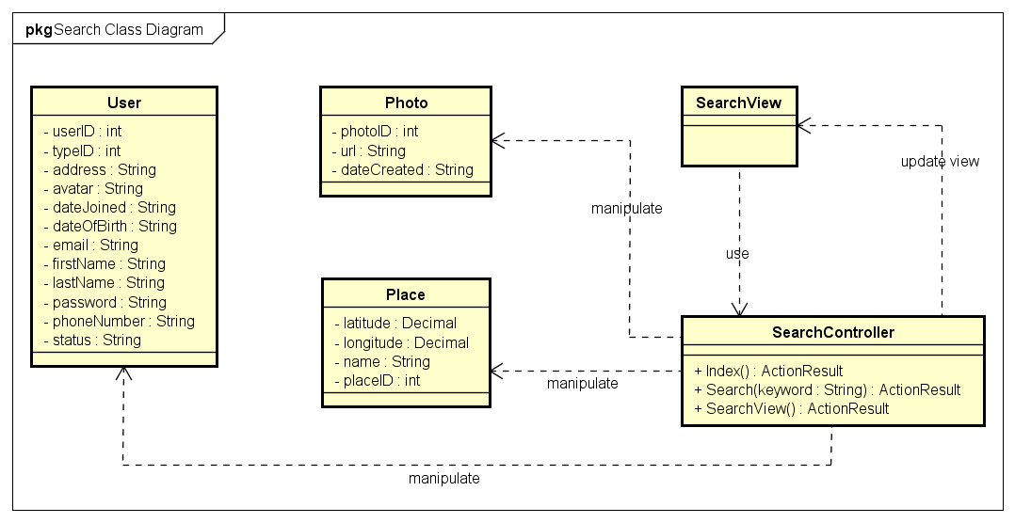

*Search Class Diagram*

|  |  |  |
| --- | --- | --- |
| No. | Class Name | Description |
|  | User | Include method interact with Database |
|  | Photo | Include method interact with Database |
|  | Place | Include method interact with Database |
|  | Search | Include method interact with Controller |
|  | Search Controller | Include method interact with Model |

### Sequence Diagram

#### Search by name

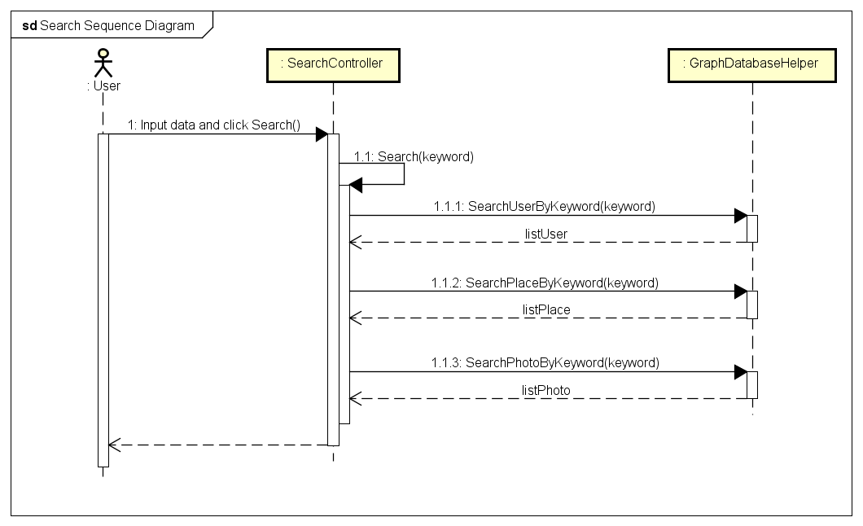

*Search Sequence Diagram*

## Help Center (Undone)

## Suggest

### Class Diagram

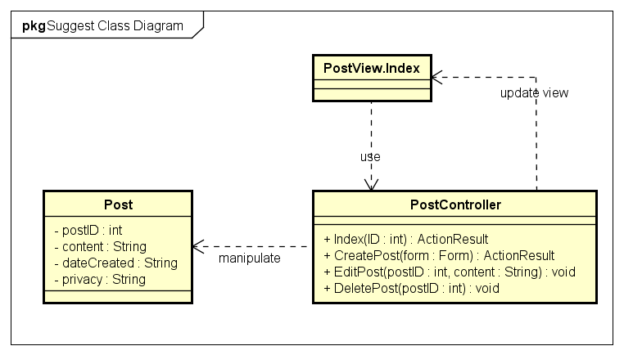

### Sequence Diagram

#### Suggest Friend

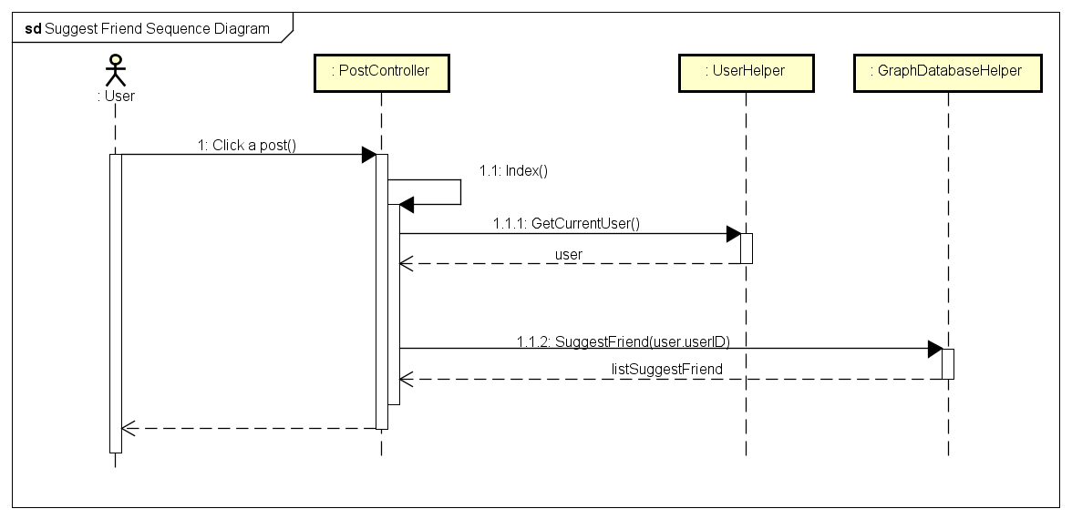

#### Suggest Place

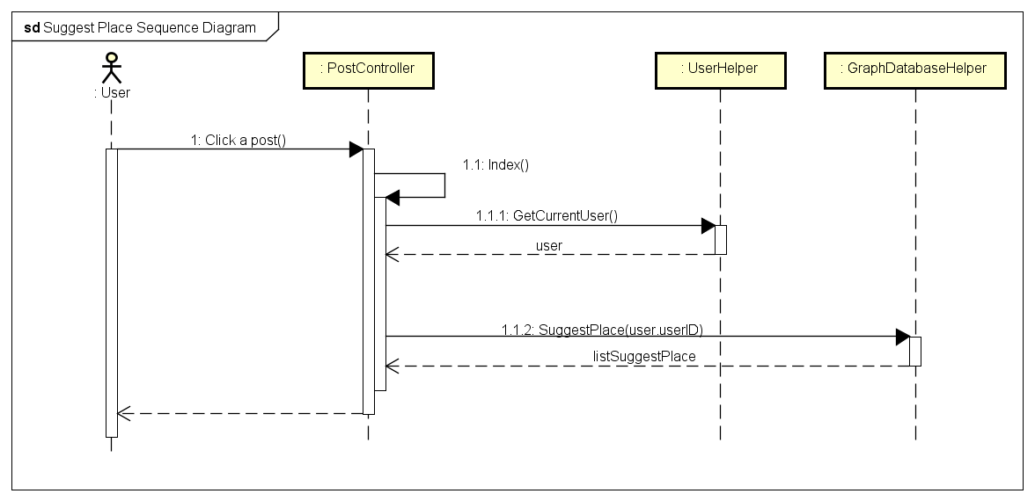

## Post Management

### Class Diagram

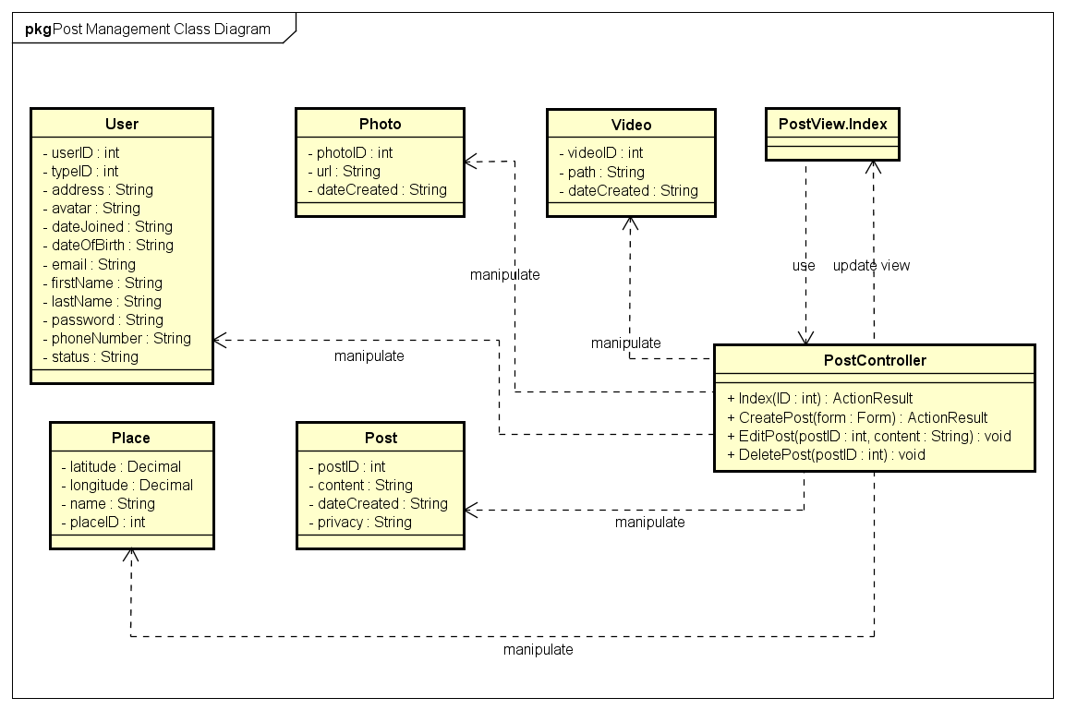

*Post Management Class Diagram*

|  |  |  |
| --- | --- | --- |
| No. | Class Name | Description |
|  | User | Include method interact with Database |
|  | Photo | Include method interact with Database |
|  | Place | Include method interact with Database |
|  | Index | Include method interact with Controller |
|  | Post Controller | Include method interact with Model |

### Sequence Diagram

#### Add Post

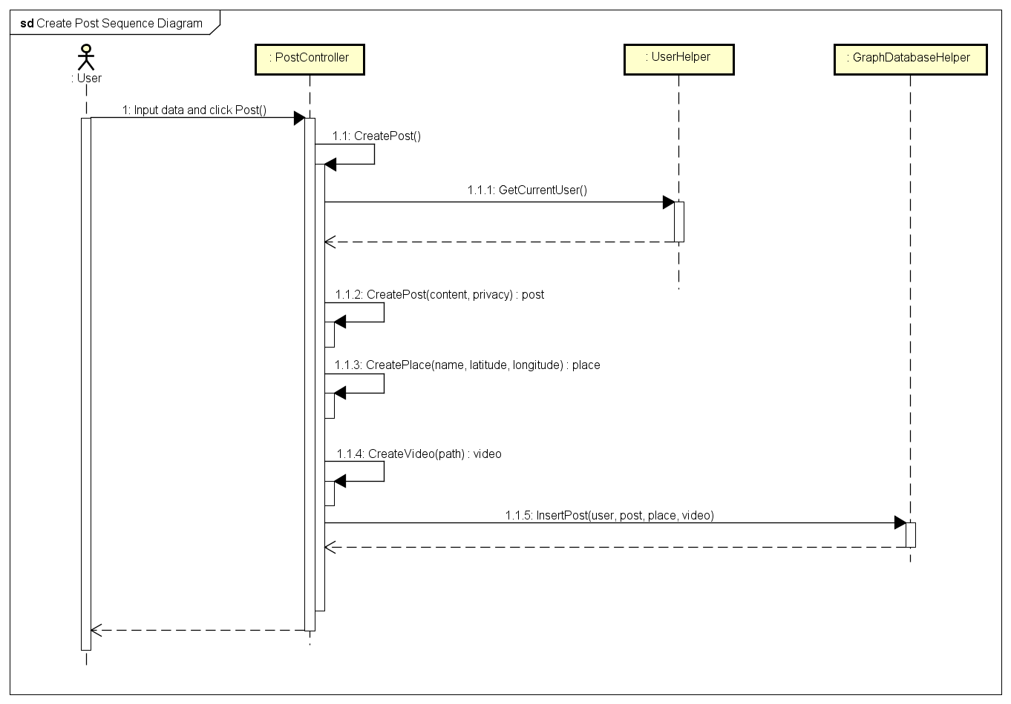

*Add Post Sequence Diagram*

#### Edit Post

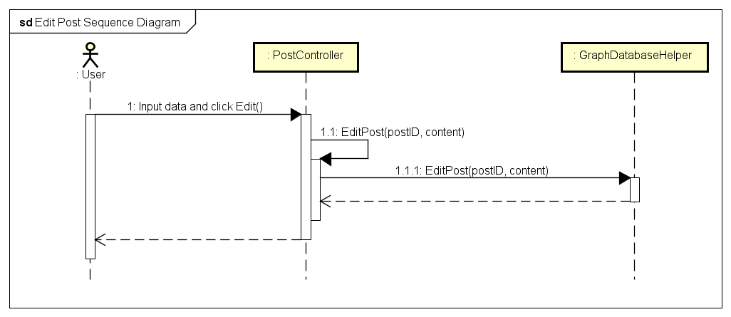

*Edit Post Sequence Diagram*

#### Delete Post

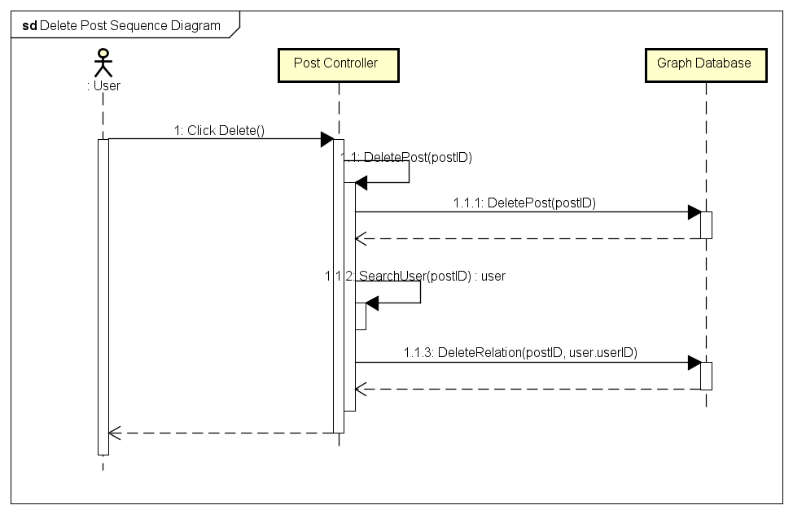

*Delete Post Sequence Diagram*

## Share Management (Undone)

## Comment Management

### Class Diagram

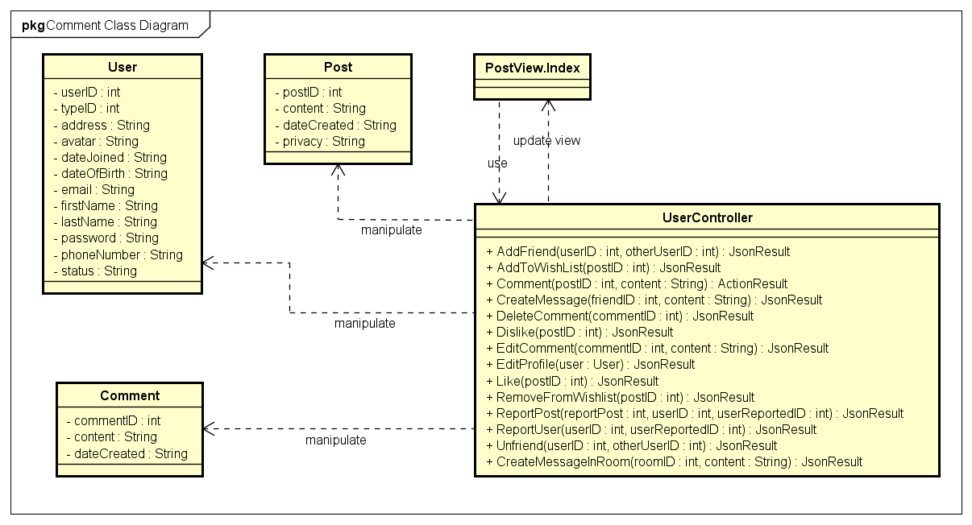

*Comment Management Class Diagram*

|  |  |  |
| --- | --- | --- |
| No. | Class Name | Description |
|  | User | Include method interact with Database |
|  | Post | Include method interact with Database |
|  | Comment | Include method interact with Database |
|  | Index | Include method interact with Controller |
|  | User Controller | Include method interact with Model |

### Sequence Diagram

#### Add Comment

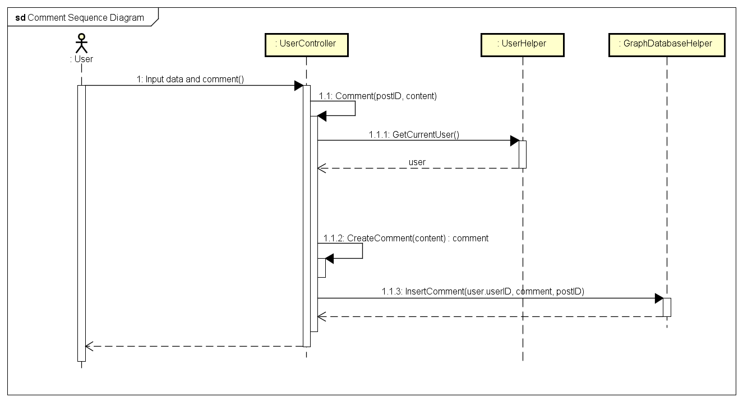

*Add Comment Sequence Diagram*

#### Edit Comment

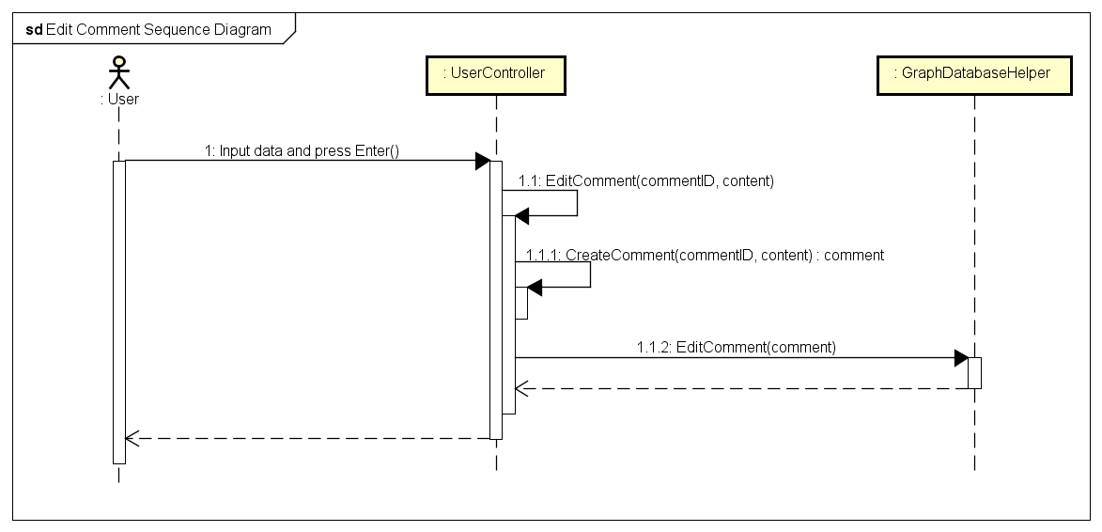

*Edit Comment Sequence Diagram*

#### Delete Comment

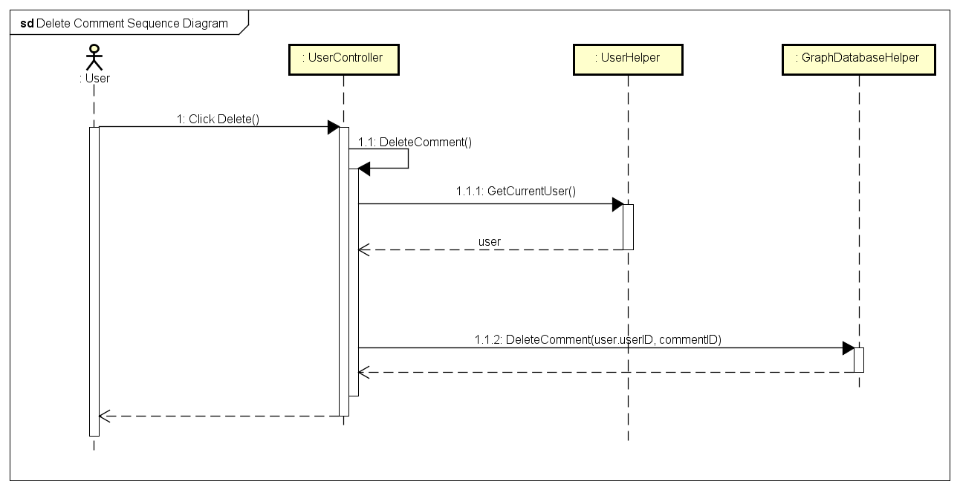

*Delete Comment Sequence Diagram*

## Like Management

### Class Diagram

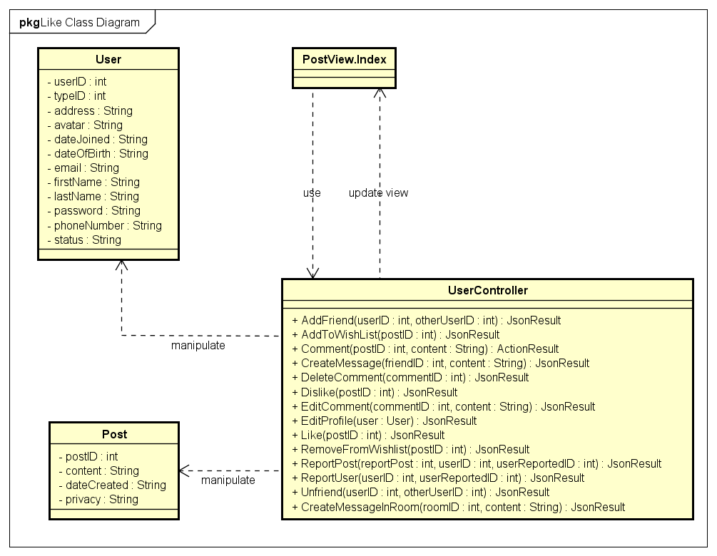

*Like Management Class Diagram*

|  |  |  |
| --- | --- | --- |
| No. | Class Name | Description |
|  | User | Include method interact with Database |
|  | Post | Include method interact with Database |
|  | Index | Include method interact with Controller |
|  | User Controller | Include method interact with Model |

### Sequence Diagram

#### Like

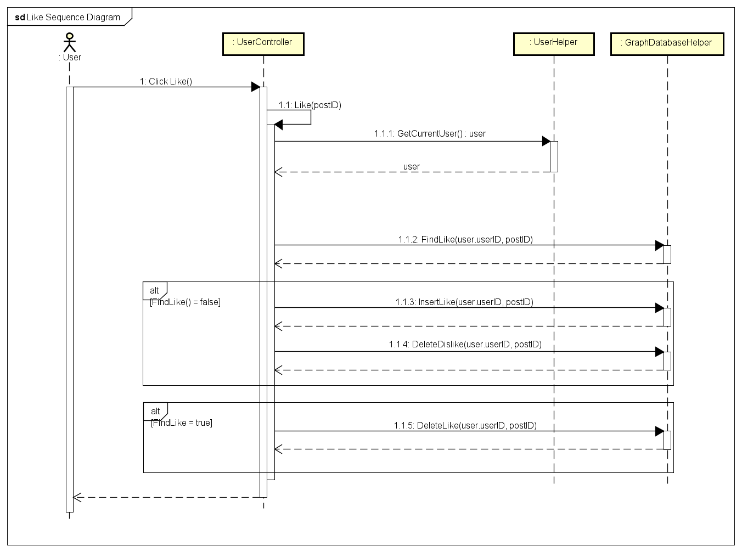

*Like Sequence Diagram*

#### Dislike

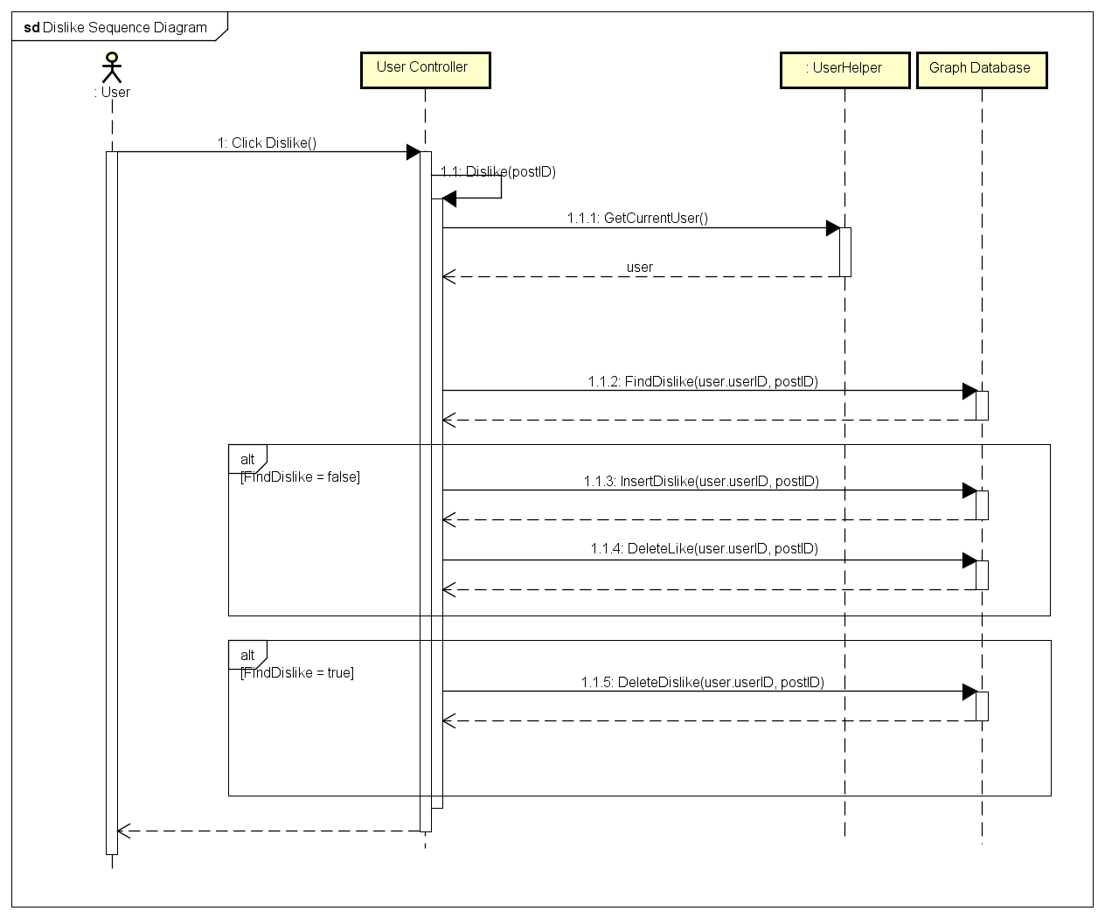

*Dislike Sequence Diagram*

## Report

### Class Diagram

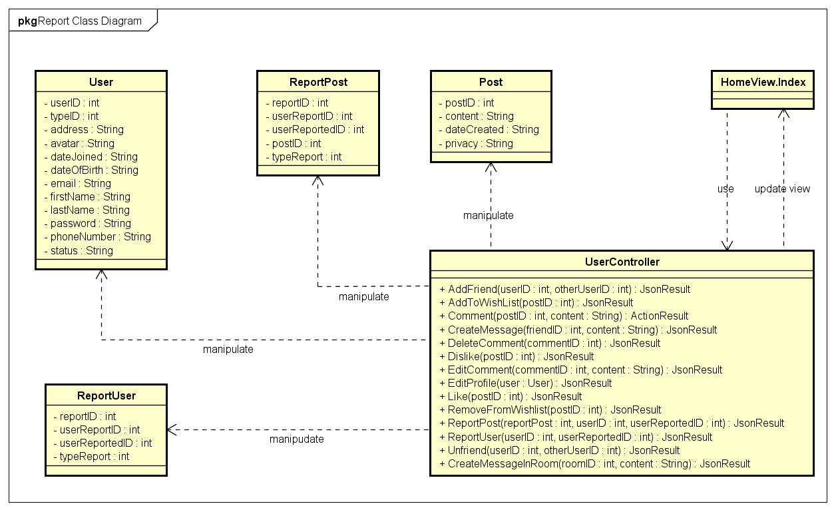

*Report Class Diagram*

|  |  |  |
| --- | --- | --- |
| No. | Class Name | Description |
|  | User | Include method interact with Database |
|  | ReportPost | Include method interact with Database |
|  | ReportUser | Include method interact with Database |
|  | Index | Include method interact with Controller |
|  | User Controller | Include method interact with Model |

### Sequence Diagram

#### Report a post

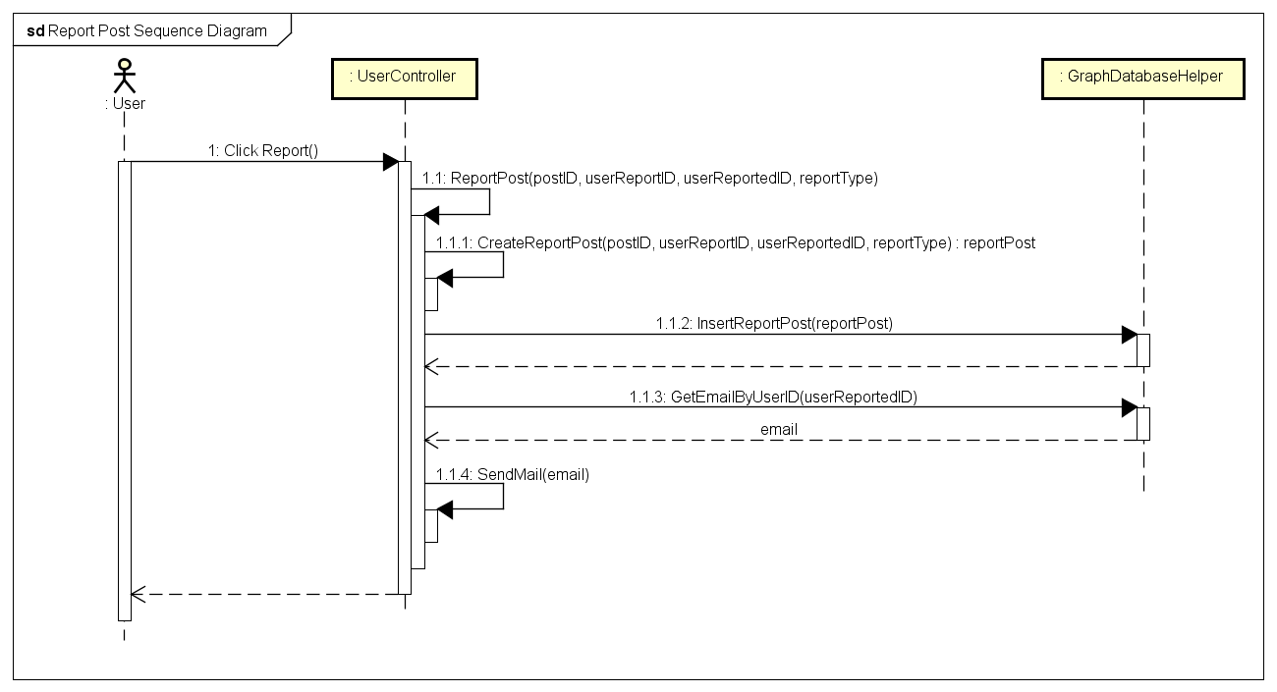

*Report a Post Sequence Diagram*

#### Report an user

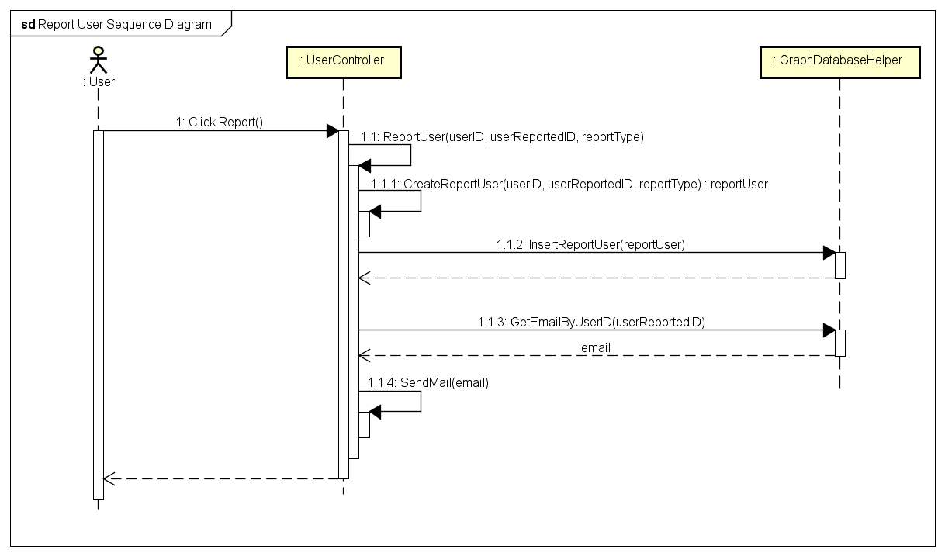

*Report an User Sequence Diagram*

## Chat

### Class Diagram

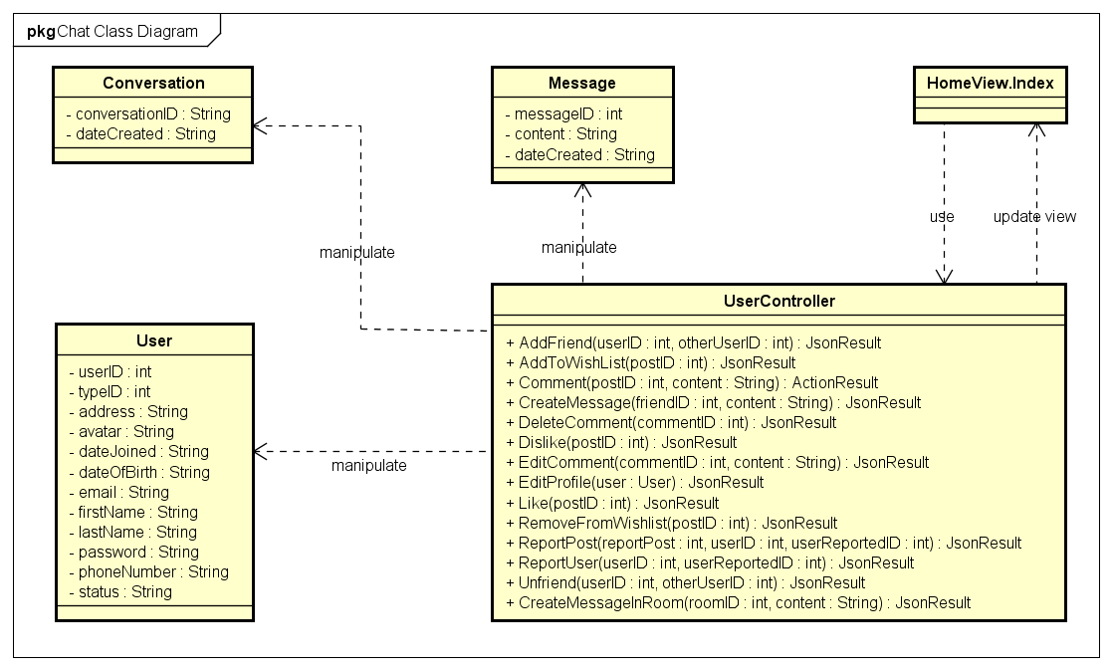

*Chat Class Diagram*

|  |  |  |
| --- | --- | --- |
| No. | Class Name | Description |
|  | User | Include method interact with Database |
|  | ReportPost | Include method interact with Database |
|  | ReportUser | Include method interact with Database |
|  | Index | Include method interact with Controller |
|  | User Controller | Include method interact with Model |

### Sequence Diagram

#### Chat

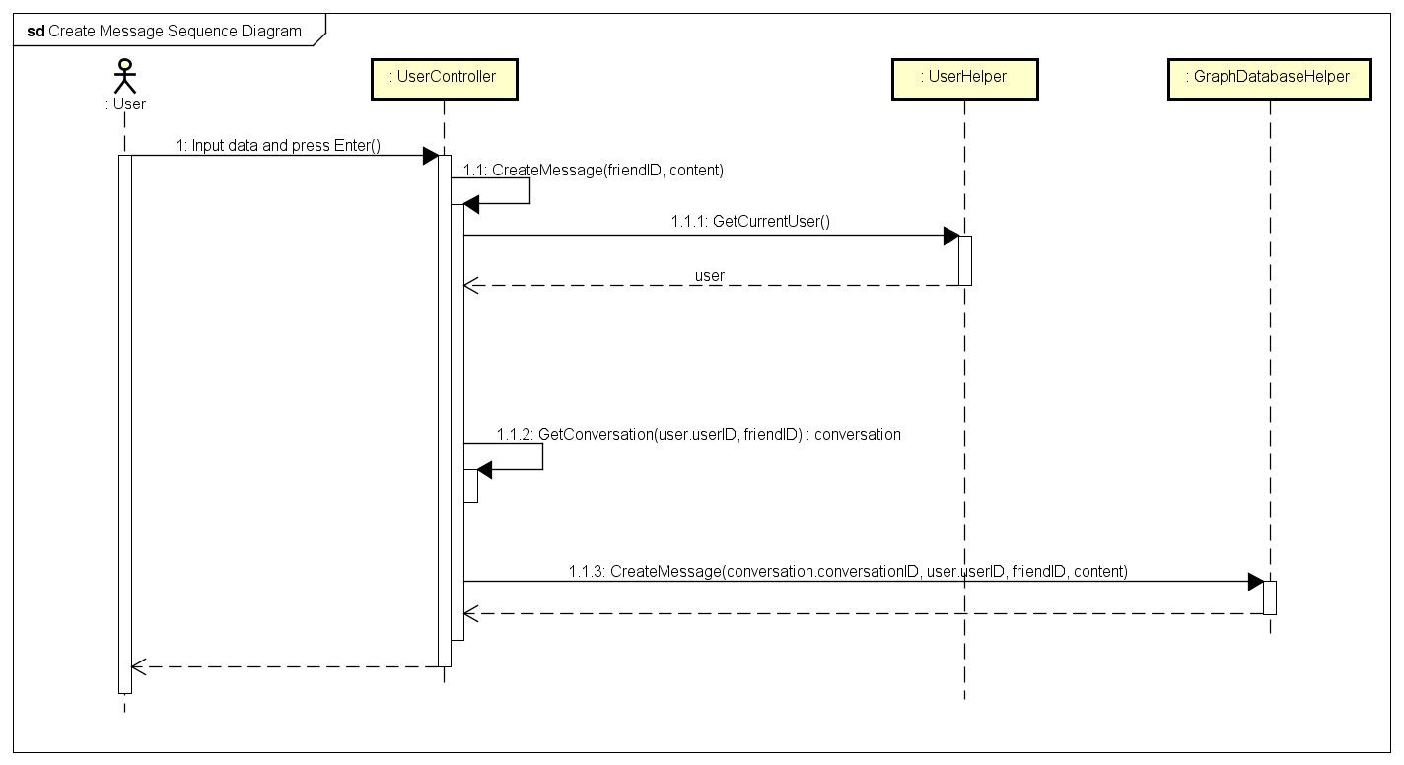

*Chat Sequence Diagram*

## Friend Management

### Class Diagram

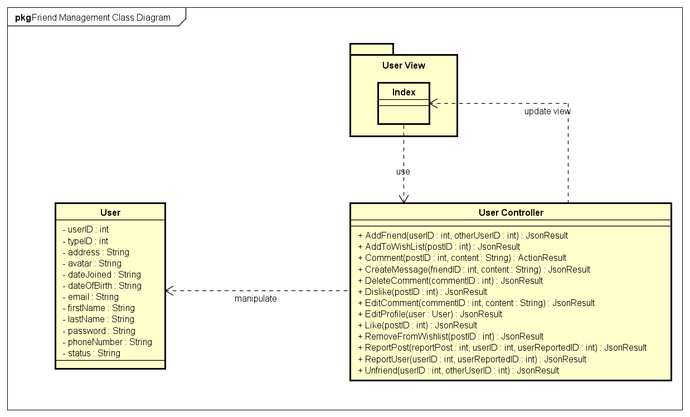

*Friend Management Class Diagram*

|  |  |  |
| --- | --- | --- |
| No. | Class Name | Description |
|  | User | Include method interact with Database |
|  | Index | Include method interact with Controller |
|  | User Controller | Include method interact with Model |

### Sequence Diagram

#### Add Friend

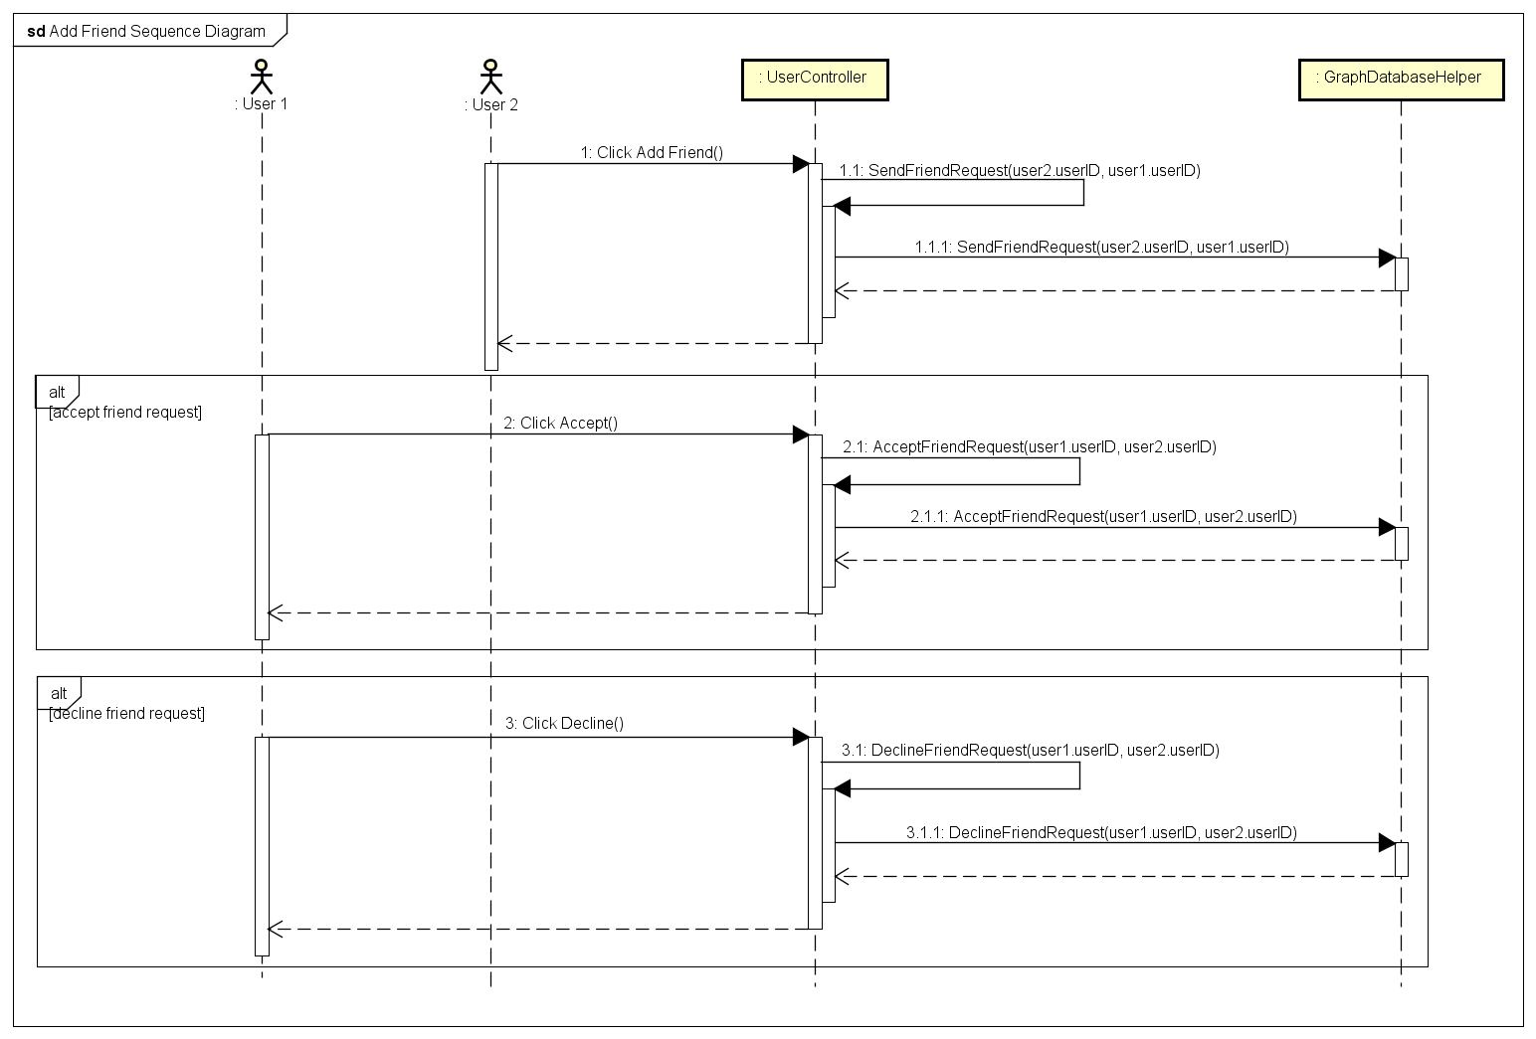

*Add Friend Sequence Diagram*

#### Unfriend

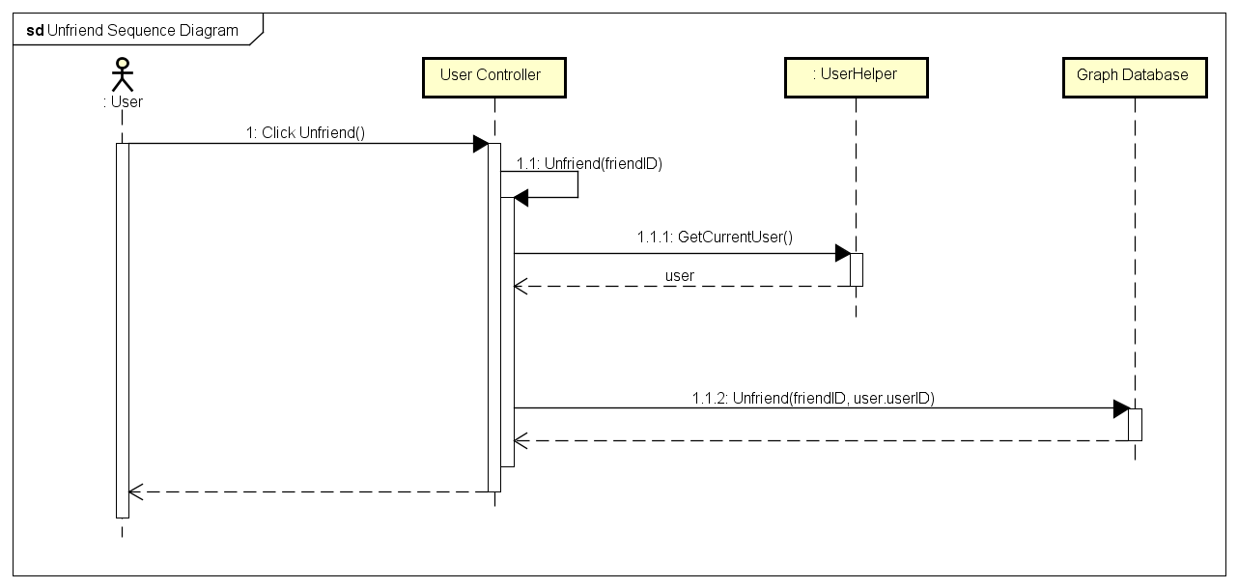

*Unfriend Sequence Diagram*

## Room (Undone)

## Account Management

### Class Diagram

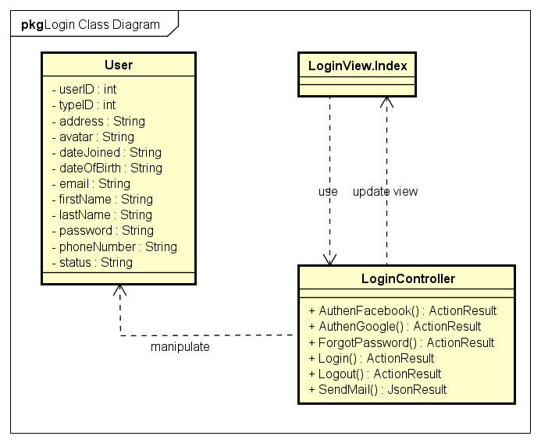

*Account Management Class Diagram*

|  |  |  |
| --- | --- | --- |
| No. | Class Name | Description |
|  | User | Include method interact with Database |
|  | Login | Include method interact with Controller |
|  | Login Controller | Include method interact with Model |

### Sequence Diagram

#### Login (Undone)

#### Logout

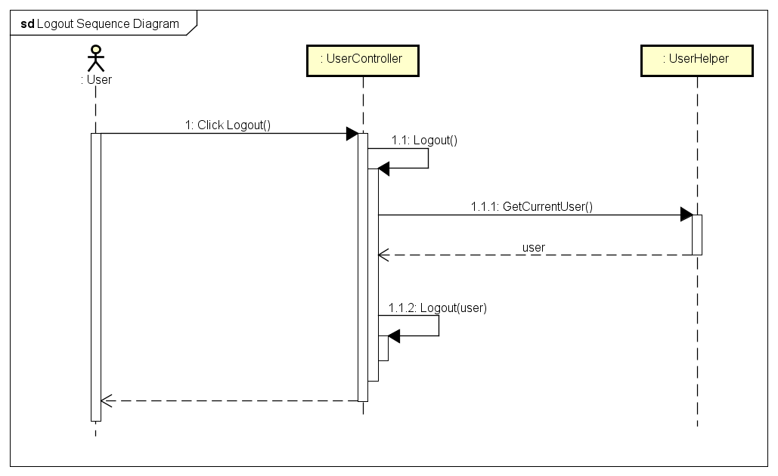

*Logout Sequence Diagram*

#### Register (Undone)

#### Edit Profile

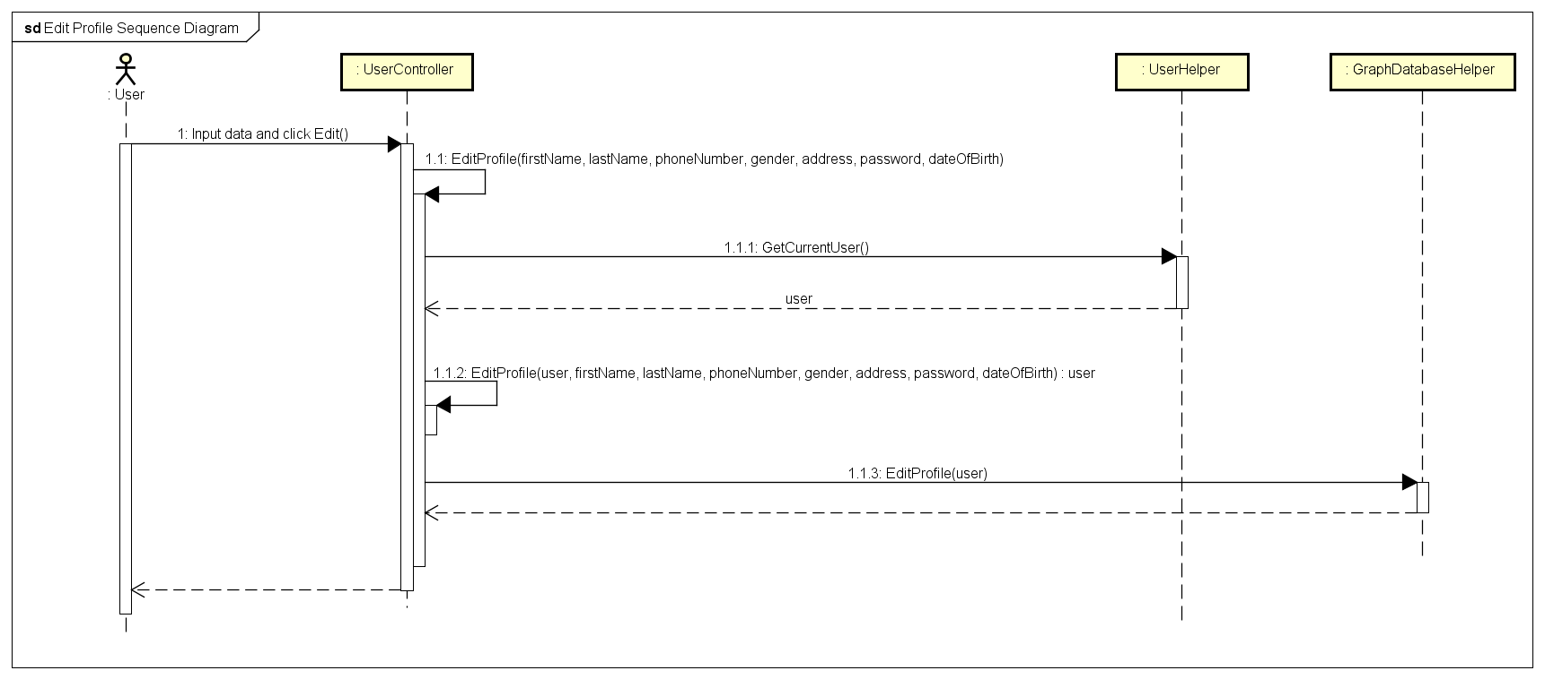

*Edit Profile Sequence Diagram*

#### Forgot Password

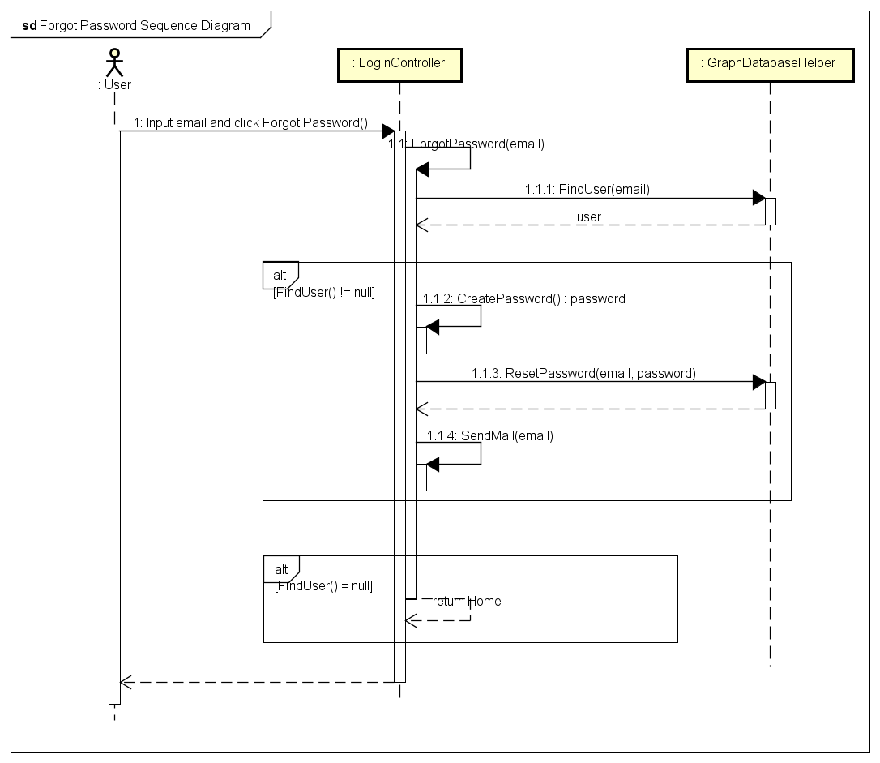

*Forgot Password Sequence Diagram*